Biodiversity Plan
2020-2025

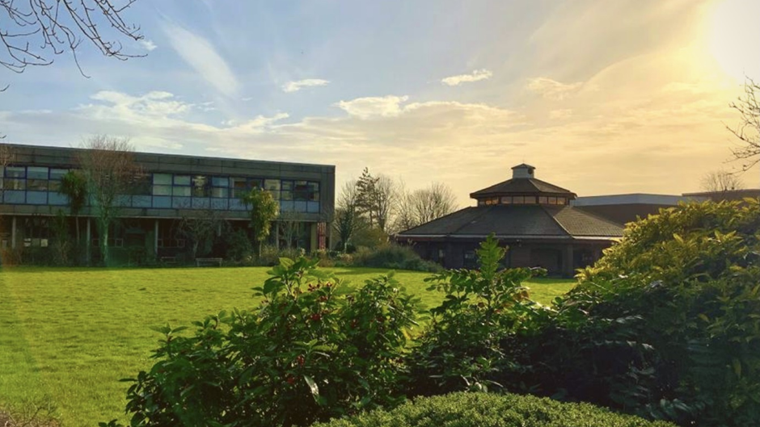

10. Biodiversity Plan
Plymouth Marjon University is located in the north of Plymouth city. The campus is approximately 17 ha in size and comprises of a variety of different habitats. To the south is Derriford Community Park, with Bircham Valley Local Nature Reserve the closest section of this to the university. To the west, on the other side of Marjon Hill, is a Site of Special Scientific Interest; Plymbridge Lane and Estover Road. This is designated for the presence of the only known wild population of Plymouth Pear Pyrus cordata, a species afforded special protection under the Wildlife and Countryside Act, 1981. Plymouth has a number of Local Nature Reserves, three of which are within 2 km from the University campus. These are Southway Valley LNR (825 m), Whitleigh Wood LNR (1.7 km) and Woodland Wood LNR (1.7 km). With these areas nearby, Marjon campus is in a position to welcome wildlife onto campus.
It is important that we not only look at decarbonising campus, but also at any carbon offsetting initiatives we can do e.g. Marjon has planted 210 new trees across campus in 2022. Providing habitats for our local wildlife e.g. our campus deer, is important to Marjon, as well as contributing to the city’s wildlife corridor. Expanding our green spaces and biodiversity of these spaces is essential for Marjon as it not only benefits the local wildlife, but also the mental health and wellbeing of our staff and students through creating more green space and outdoor seating.

10.1 Biodiversity Survey 2021
In 2021 the Devon Wildlife Trust completed a Biodiversity Survey of campus. The purpose of the survey was to:
• Provide details of habitat types on site
• Provide recommendations for improvements to these habitats
• Provide management suggestions to attain these improvements
• Provide recommendations for enhancements to benefit wildlife
The findings from the survey have helped to steer this biodiversity plan. Marjon plans to monitor ongoing progress through biodiversity surveys to help compare and monitor progress and assisting with planning for the future.

  - Meadow & Wildflower Areas
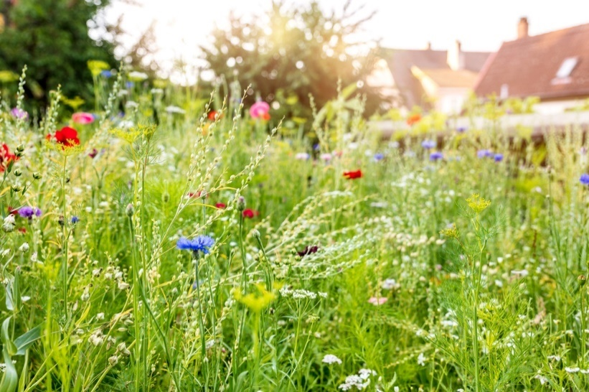
Wildflower habitats are a priority habitat in the Devon Biodiversity Action Plan (DBAP). A big job that wildflowers undertake is to provide bees, butterflies and other pollinators with food sources throughout the seasons, and that is why a wide range of wildflower species are required. Wildflowers provide pollinators and insects with food from leaves, pollen, nectar, shelter and places to breed. Pollinators then return the favour by transferring pollen, enabling the wildflowers to develop seeds that produce more flowers.
Marjon’s plan is to increase its ‘un-mowed’ sections of grass to allow for wildflowers and grass meadows to flourish. As stated in the 2020 Campus Development Plan, by 2030 Marjon plans to reduce the amount of parking on campus and situate all parking in the north-east section of campus so that we can allow for more pedestrian and outdoor seating areas as seen in the map below.

The management:

The meadows will need to be cut three times a year.

Cut 1: Early Spring / March
The first is in March just as spring emerges. This is when the meadow is in need of easy access to light and water.

Cut 2: August
This is because wildflowers will usually have set and dropped their seed, meaning you can cut them back again to keep the competing grass under control. Aim to keep sward height low (approximately 5 cm).

Cut 3: Autumn Cut / September – October
This is the last cut of the season and usually the lowest. You can pretty much cut as close to the ground as possible for this cut. It sets up the meadow for overwintering and enables light to get to some seedlings that will germinate before the winter months.

The cuttings will need to be removed from these areas helping to reduce the fertility of the soil. Low fertility soils are key to wildflower regeneration as it helps to supress the grasses.

So that we have an area where invertebrates and other animals can spend the winter, we should leave the large grassland area by the hockey pitches uncut throughout the year. However, it will need to be managed once every 2-3 years. As noted in the biodiversity Report, our scrub land is due some clearance. This scrub clearance should take place over winter, to avoid disturbing nesting birds. The aim of scrub clearance should not be to remove scrub entirely, but to trim it back. This should be done using hand tools, rather than heavy machinery which would crush the grassland.

  - Tree Planting
In 2022, Marjon University partnered with the Woodland Trust to plant 210 trees across our campus grounds. These included a variety of tree species to aid in the increase in biodiversity across campus:
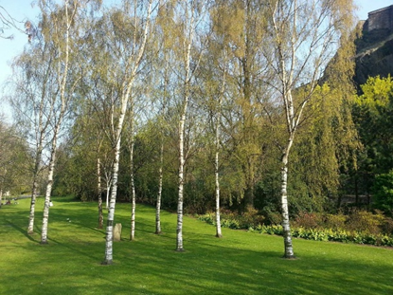
- Hazel
- Blackthorn
- Crab Apple
- Elder
- Dog Rose
- Rowan
- Hawthorn
- Dogwood
- Wild Cherry
- Silver Birch
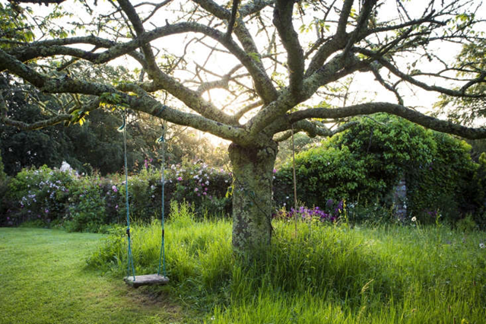
We also plan to better manage the trees we have on campus e.g. by helping tree saplings survive grass competition by putting mulch rings around them.
For our more mature trees we will be leaving ‘grass necklaces’ to protect the trees roots from ride on mowers and strimmer’s. They will also help to reduce footfall in this area which can usually compact the base of the tree.

10.4 Bees
In 2021 Marjon University partnered with Plymouths’ Pollenize to be home to two new beehives.

Pollenizes’ mission is to:

- In Plymouth, to create a network of community-funded research beehives (also called apiaries) stocked with European Dark Honeybees. Pollenize get their stock from Mount Edgcumbe Cornish Bee Group, the UK’s first Black Bee Reserve.
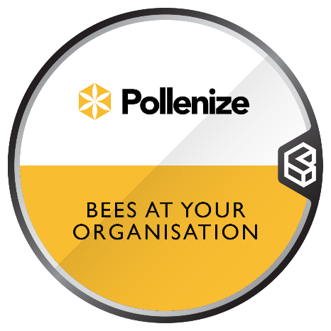
- This is to conserve and extend the local populations of our threatened native dark honeybee.
- The iconic businesses and buildings where Pollenize keep their colonies of bees help amplify their message of pollinator conservation, as well as showing the importance of collaboration in the city.
- Pollenize uses the power of community and science to fight against pollinator decline.
- Pollenizes’ mission is to promote and protect all pollinator species by bridging the gap between people and science to provide tangible solutions for our climate emergency.
- Their work involves extracting data from our beehives for betterment of the natural environment whilst coordinating community beekeeping, citizen science and public-led rewilding schemes.
- Their research on the honeybee will be used as a bioindicator of the health of our environment and as a vehicle to green recovery.

DNA Pollen Analysis:

Pollenize works with local scientists from the Electron Microscopy Centre (PEMC) at The University of Plymouth to conduct DNA analysis on the pollen residue left by our bees, this then tells us exactly which species of plants they are going to.

Using bees as a biosensor Pollenize can identify any gaps within the foraging radius of the beehive and use this information to create seed packet recipes that will address these floral gaps.
They believe this to be a true lifeline to our local ecosystem, not only honeybees, but all other wild insects and pollinators as well.

Live Steam Camera:

Soon (Summer 2022) we will have a camera installed into one of the hives so we can live stream them 24/7.

Beekeeping:

Students and staff can also get involved in the weekly beehive inspections with the Pollenize experts. This gives them the opportunity to learn more about their local pollinators, the importance of their protection and proper beekeeping methods.

10.5 Sustainability Campus Trail
Marjon University plans to create a sustainability trail across campus compromised of educational trail boards.
The trail will focus on the sustainability achievements to date across the university e.g. GSHPs and solar panels, looking at how they work and their environmental benefits, along with highlighting the campus biodiversity.
The boards will have a focus on education for all ages, with worksheets provided for younger children that may visit site (inc. Flying Start Nursery located on campus).
We wish for Marjon to become a hub for sustainability education and to highlight our achievements allowing for education as well as providing ideas for other people and organisations to use through sharing best practice of innovative ideas.
A lot of the time improvements can’t always be seen e.g. solar panels are on our roofs, GSHPs underground and biodiversity of plant species are often unknown. By pointing out the variety of plant species on campus and their individual benefits to the local wildlife then people can begin to appreciate the area more and how each plant plays a part in the survival of our wildlife, be it food or shelter.

10.6 Campus Allotment
Marjon University has a campus allotment located behind our student village houses. The plan is to re-launch this so that it gets more use. This can be done by the creation of a student society group who manages the allotment. We also plan to tie in the allotment use with our cooking lessons we wish to host with our catering providers. Students and staff can grow fruit, vegetables and herbs and then learn a good recipe to cook with these items.
This will help teach students about seasonal cooking and eating and how to grow and care for the fruit, vegetables and herbs.
The practice of using the allotment also acts as a way to socialise with others or could be a break in a staff members working day to get some fresh air and move their body. Whatever the activity, getting staff and students outdoors will benefit their mental health and wellbeing.

  - Sensory Garden
The creation of a sensory garden on campus will allow for unused space to have a designated purpose that benefits both biodiversity and the community.
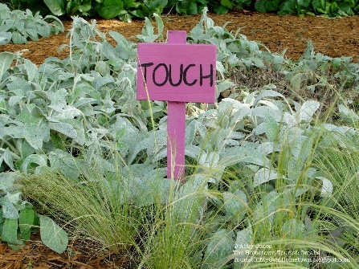
It would allow an enclosed space for students to go and relax and clear their head. With mental health issues on the rise, Marjon believes such a space will be utilised and appreciated by not only students but staff.
A sensory garden allows you to focus your attention on nature, helping students to appreciate their surroundings and its ability to ease any stressors you currently have in your life.

10.8 Student, Staff and Community Engagement
Marjon wishes to engage staff, students and the local community with the education and implementation around the campus biodiversity improvements. Activities such as upcycling materials that were once ‘trash’ e.g. rubber tyres into flower pots, or the building of hedgehog homes and bug hotels. It’s important that engagement activities are educational and fun for all.
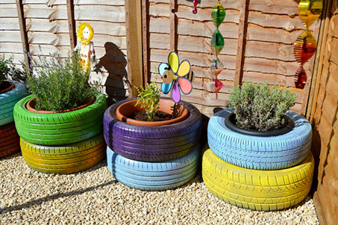
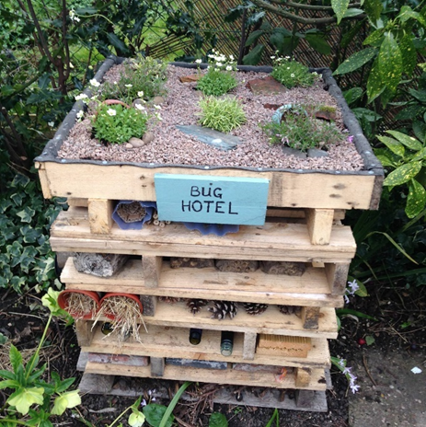
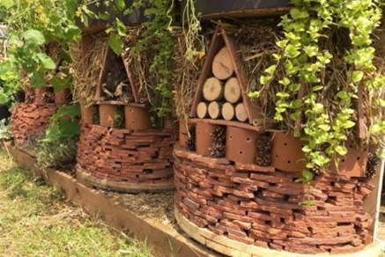

  - Summary of management for different key species:
Invertebrates
Shelter can be provided in key areas of the campus, to help invertebrates, particularly over winter. “Bug hotels” are a good way to provide shelter opportunities. Suggested locations for bug hotels/bug boxes on campus include near the pond, in the allotment area, in the southwest corner of site and finally provision in the north of the campus, near the entrance.
Mammals
Marjon already has 4 hedgehog boxes on campus, and we are currently working towards our Hedgehog Friendly Campus Accreditation, however more boxes are always beneficial. Boxes should be placed in areas where they will not be disturbed, are away from direct light sources and sunlight (to help keep the internal temperature stable). Hedgehog boxes need yearly maintenance, as hedgehogs can be prone to parasites and so we will clean them out each spring to help keep the hedgehogs healthy. There are already a few bat boxes on campus, however, more can be added in the woodland areas. Bat boxes should be placed at least 4m from the ground, away from artificial light sources and strong winds/weather and positioned so that they are away from the north side of the tree. Bat boxes should be regularly cleaned in spring by a licenced bat worker. Bats and their roosts are protected under law (Wildlife and Countryside Act 1981). There is an active badger sett on campus which will be left undisturbed as they are protected under law.
Reptiles and amphibians
Suggestions from the Biodiversity Survey focus on removing bankside vegetation to allow more light to reach the water surface, which will encourage plant growth and in turn create habitats more preferable to invertebrates and amphibians. As well as a good source of water, they also need adequate shelter. Creation of hibernacula would provide this. A hibernaculum is a place where amphibians and reptiles can find shelter particularly over winter, and they are simple to create. A hole filled with sticks, stones and other items provides reptiles and amphibians with shelter which, in the colder months, will not fluctuate in temperature as much as the surface does. This hole is then recovered with the earth. Another simple structure is a log pile.
Birds
There are a variety of habitats on campus, many of which are suitable for bird nesting and foraging. A key to encouraging bird life is to provide a food source. By implementing the above management suggestions, invertebrate numbers should increase, which would support more birds. To increase the nesting opportunities, bird boxes can be placed around the campus. House sparrows (Passer domesticus) are small, social birds, which nest in groups. Populations have declined substantially, and this species is red listed on the Birds of Conservation Concern2 publication. Two sparrow terraces could be erected on trees or quiet buildings to help this species.

