Notes for Elections Team
How to Vote
From 12 Noon Thursday 14th all registered students at Marjon will receive in their University email account (Outlook) an invitation to Vote from the MSU. The "Vote now" link will only become active once the elections open from Friday 15th March at 9AM. You can change your vote as many times as you like but only your last vote will count. Voting will close at 3pm Friday 22ND March.
You can find your MSU invitation email in your University email account. You can further search for the email by typing "msu" in your search box and look for "msu@marjon.ac.uk" titled "MSU ELECTIONS 2024"
Please keep this email until you are ready to vote! If you have deleted this email contact ktraynor@marjon.ac.uk to request another email key is sent to your email account to allow you to vote.

Important Voting Information
For each position, rank each candidate by preference. A rank of 1 indicates your most preferred candidate. To register your votes, all candidates must be ranked including "RON Re-Open Nominations"
If you fail to rank a candidate, your votes will be considered void and will not be counted when calculating the election results. So for example if there is 3 candidates for President always rank 1, 2 and 3 (Including RON) & for if for example there are 4 candidates for Deputy 1, 2, 3 and 4 (Including RON)
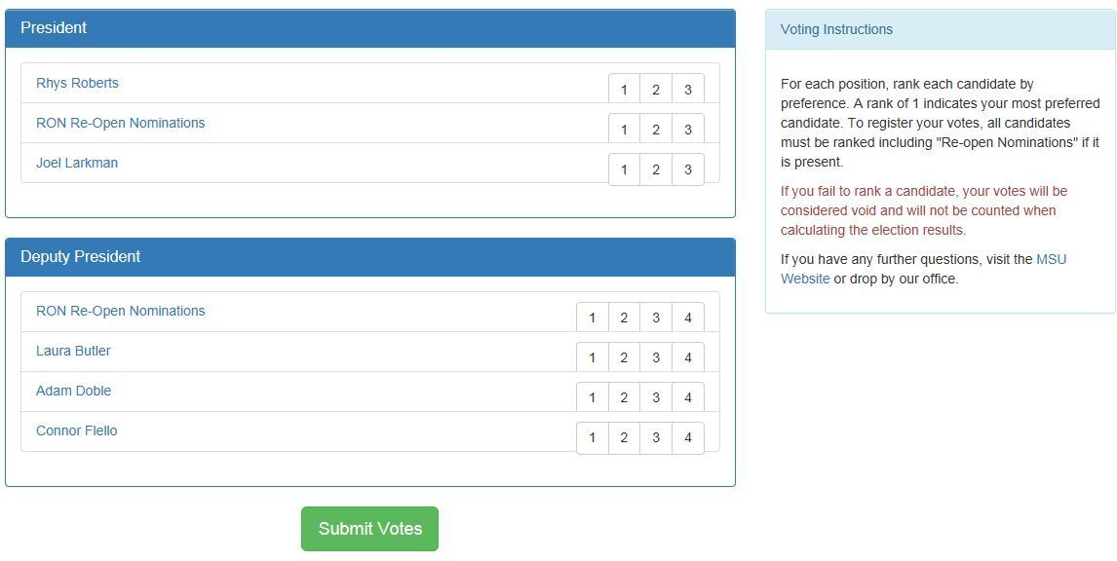

Didn't Receive your email or Deleted email
If you did not receive your email or have deleted it, please contact Kevin Traynor ktraynor@marjon.ac.uk with your full name, course and contact number.

