Trustee Board Meeting TB21/SB/1

___________________________________________________________________

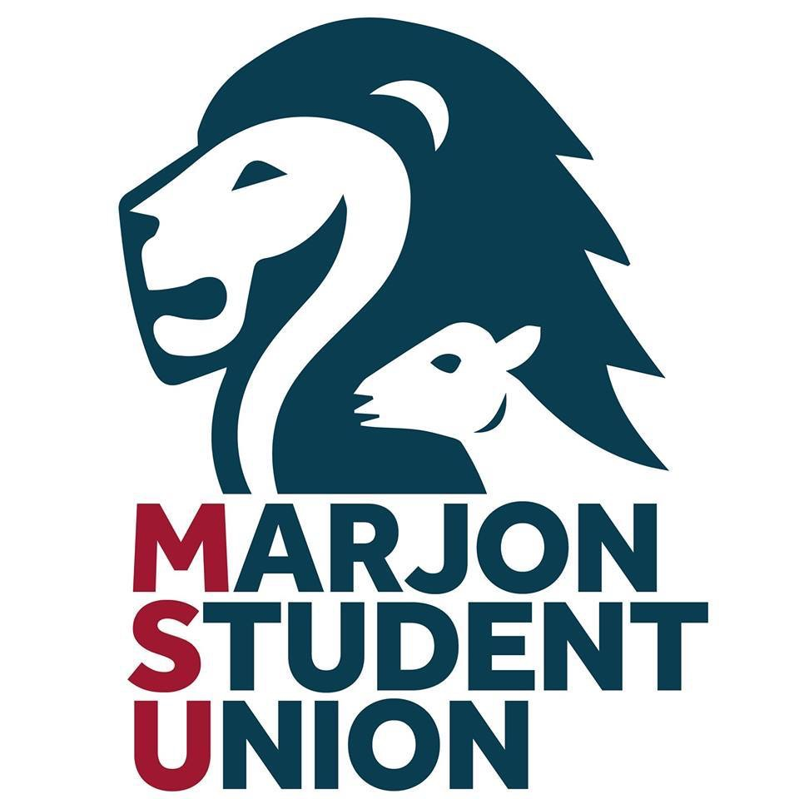
27th September 2023
1500 -1700
Facilitated virtually on Teams

MINUTES (Approved)

_________________________________________________________________________

Invites extended to: Sarah Boyd (Marjon SU President & Trustee Board Chair), Daniel Tinkler (External Trustee & Trustee Board Vice Chair), Liam Williams (Marjon SU Deputy President), Graham Briscoe (External Trustee), Dev Aditya (External Trustee), Ania Jackowska (Student Trustee), Chloe Lewis (Student Trustee), Mick Davies (Marjon SU GM).

Present:
Sarah Boyd (President & Trustee Board Chair) SB
Daniel Tinkler (External Trustee & Trustee Board Vice Chair) DT
Liam Williams (Marjon SU Deputy President) LW
Graham Briscoe (External Trustee) GB
Ania Jackowska (Student Trustee) AJ
Mick Davies (Marjon SU GM- in attendance) MD

All papers had been previously circulated by MD.

1. Welcome and introductions from the Chair: SB Sarah Boyd, newly elected President, welcomed all to the meeting, and introduced newly elected Deputy President Liam Williams to the board. They introduced themselves in turn.

2. Apologies: SB Apologies were received from DA (External Trustee) and CL (Student Trustee).
3. Update from the VC:
With reference to: Vice-Chancellor’s Bulletin w/c 04 September 2023 (Published 07/09/23 on Plymouth Marjon University – Antler)

The VC thanks SB and LW for inviting her to address the board and took the opportunity to update on the University. She made the initial point that Marjon continues to “box above its’ weight” achieving Gold in TEF 2023. After delivering the report the VC invited questions.
DT asked if Marjon would be looking at international recruitment and did she have any concerns around particular course groups where the SU could be of value by providing a strong rep system and or academic societies etc.
The VC answered the board stating that she didn’t have any major concerns. However, there were courses where the cohort is quite small, and their student experience needs to be monitored. She welcomed MSU’s offer of being involved in course representation and ensuring consistency of how this is done and that we are considering post grad provision as well as academic apprenticeships,
(education and nursing).
On international recruitment she stated that it is likely the University will be looking at development strategy recruitment in the future.
DT expressed that this would be the same for the SU that it has to re-examine its’ model for representation.
AJ asked how students will be involved in the University’s strategy development.
The VC replied that whilst they will not be starting from a blank sheet of paper, she is keen that the University connects with all of Marjon (students) making sure to not miss out postgraduates and research students. Whilst the exact nature of engagements was yet to be determined she would expect to see things like “Word Cafes” and would expect the SU to play a major role in this.
GB commented that he felt that MSU needs to strengthen its representation of postgraduates. He asked the VC what her thoughts were on supporting the Student Union to represent these students. The VC explained that the shape of Marjon students is likely to change over the next few years with more work- based apprentice degree students, postgraduate research courses and that all of the University and the MSU will need to work together to make sure that all of these students enjoy the facilities of Marjon and that each student enjoys the best possible student experience
SB thanked the VC on behalf of the whole board. All agreed that her attendance, and update was extremely informative, and they were all very grateful.
4. Declaration of Interest: SB
DT confirmed that he was now a trustee of York and St John. There were no further declarations of interests other than those previously recorded.
5. Minutes from the May meeting: (TB20/WM/1) SB
The board considered and approved the minutes from the May meeting.
6. Continuation in Student Trustee role: SB
Ania and Chloe have applied to extend their year as a Student Trustee. MD left the meeting and the board unanimously voted both to continue.

7. Matters arising: (action grid attached) SB
SB continues to explore the possibility of additional grants for project work within the SU. Action SB

8. Report from Officers: SB
SB delivered her report (TB21/SB/LW/1)

She highlighted the work she was doing on the student rep system and a briefing that she has given to the executive management team of the University.
DT asked what the Student Union was intending to do to make sure that course reps were supported and trained.

SB replied that although training is provided there is certainly room for improvement.
DT suggested that there was an opportunity for the Student Union to become much more involved with the training and supporting the University. He went on to suggest that this would be a great opportunity for a student intern role within MSU. He felt it was important that the course rep system cannot be solely run by the University as there may be issues where the University is criticized.

DT asked exactly what we mean when we talk about student engagement: Is it in decision-making, student life, and entertainment?

SB replied to his question by saying that engagement with certain groups of students is particularly difficult for both the Student Union and the University, non campus students, mature students, distant students are all challenging. There are plans to increase the digital communication to these students and going forward this was something that certainly the University and the Student Union will be looking at in partnership.
DT made the point that there is a large difference between communicating with and engaging with students.
LW went on to report an update on his work with academic societies which was going very well, He was able to report that much of the Societies grant had already been distributed.
However, he sees this as a good news story, societies are extremely active.

Following a question from DT, LW was able to provide the following academic societies list:

Active Societies as of July: 7
- LGBTQ+
- Bed Primary
- Mature Student
- Moolay (A men’s mental health group focusing on the mullet haircut)
- Blackball pool
- Games Night
- Uni Boob team

9. Report from GM: MD
- Performance against Budget, Q4 (TB21/MD/1)
MD presented the previously circulated budget report and briefly informed the board that, despite an extremely challenging year, there was a tiny cash surplus of £600 which would be carried over into societies and campaign funds. This position may of course change when we receive the full annual financial statement, as they will account for a reduction in the pension deficit. There then followed a brief conversation regarding incorporation.
DT asked if MD could produce a brief paper again on incorporation for the December meeting. Action MD

- Trustee Recruitment update
MD reported that trustee recruitment was going well with applicants in from both students and externals, the closing date for applications is midday on Friday 27th October 2023, whereupon a team from the board will be assembled to interview.
DT recommended that if we have more students than positions, that students were taken on as an associate member of the board with regards to becoming permanent full member at a later date. GB confirmed that this is common practice however, the associate members will of course have no voting rights.

- Partnership agreement
MD reported on his previously circulated notes on the partnership agreement. The board then engaged in a brief conversation about what they would like to see from the partnership agreement, what have been issues and problems for the SU in the past and how could the agreement help to rectify these.
The recommendation was reached that there's a series of operational appendices that could be written.
GB suggested that MD starts to draft them and presents them to the Vice Chancellor initially for consideration before wider circulation.
DT asked if there was any opportunity to re-examine the relationship with Chartwells bar take and entertainment.
MD replied that there were proposed changes in the way that Chartwells would be operating, and we would have a look at how entertainment maybe funded going forward.

10. AOB
One item of any other business came from SB who announced that she and DT were planning to have a series of individual conversations with trustees regarding their own personal development, this was the final outstanding recommendations of the governance review.
Action SB

11. RESERVED BUSINESS

Action By Whom Date
5. | To continue exploring for additional grants for project work within the SU | SB | Ongoing
9. | Provide a brief paper on incorporation | MD | December meeting
10. | Plan individual conversations with trustees regarding their own personal development | SB | ASAP

