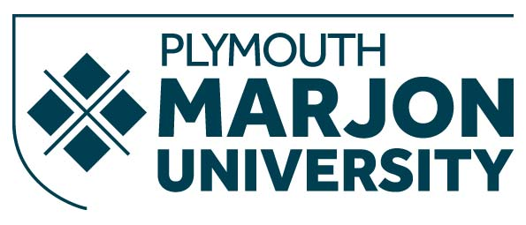

Health & Safety Policy Statement of Intent

The objective of this policy is to attain and maintain high standards of Health & Safety performance throughout the University of St Mark and St John (Marjon) for staff, students, contractors and visitors. All persons conducting activities under the name of Marjon will adhere to this Health & Safety (H & S) Policy.
Marjon will comply with the Health & Safety at Work etc. Act 1974 (HASAWA 1974) and Regulations subsequently laid under it and meet the standards required therein. Significant hazards will be identified and the risk of injury, disease or dangerous occurrence will be minimised by the achievement and maintenance of high standards of H&S.
These standards will be achieved, so far as is reasonably practicable, by:
• Demonstrating a visible management commitment to high standards of H & S performance and the promotion of a positive H & S culture throughout the university.
• Providing and maintaining safe working conditions, equipment and systems of work for all employees, students, contractors and visitors as required by legislation, Approved Codes of Practise and recognised Good Working Practises.
• Having in place adequate arrangements for the regular assessment of work activities in order to identify related significant hazards and to control associated risk.
• Having in place effective systems to protect employees and other persons affected by Marjon activities.
• Implement Safe Systems of Work and provide such information, instruction, training and supervision as is necessary to ensure the health and safety of employees, students, contractors and visitors who may be affected by activities of the University.
• Monitor and review the effectiveness of Marjon’s H & S arrangements and make improvements where identified. • Obtaining the co-operation of employees in enabling statutory obligations under health and safety legislation to be met.
Signed: Professor Rob Warner, Vice-Chancellor
Date signed: 09 Dec 2019
Next review date is Dec 2020

