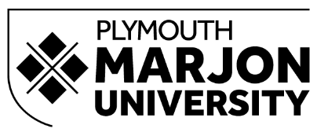
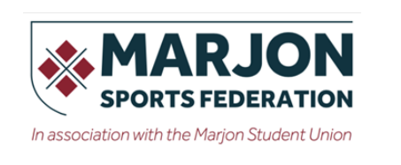

Social Media Guidelines for Marjon Sports Federation (2026-2027)
As a member of the Marjon Sports Federation (MSF), you represent your club, the Sports Federation and Plymouth Marjon University. Whether you are posting through an official club or team account or using your personal social media in connection with Marjon Sport, you are expected to act responsibly and respectfully.
These guidelines should be read alongside Plymouth Marjon University’s Social Media Policy 2026, which applies to Marjon clubs and societies as well as other University-branded social media accounts.
Read the University Social Media Policy 2026

When using social media, you should:
- Treat teammates, coaches, officials, opposition teams and other users with respect.
- Promote the positive values of sport, including fair play, inclusion and good sportsmanship.
- Never post discriminatory, abusive, threatening or bullying content.
- Remember that humour, banter and in-jokes can easily be misunderstood when posted publicly.
- Think carefully before liking, sharing or commenting on content that could be considered offensive or inappropriate.
- Only share accurate and verified information through official club or team accounts.
- Consider the privacy of others before sharing photographs, videos or personal information.
- Remember that anything posted from an official Marjon account represents the University as well as your club or team.
- Seek advice before responding publicly to complaints, negative comments or potentially sensitive issues.
Managing a Marjon Sport social media account
All social media accounts representing a Marjon Sports Federation club or team are considered University-associated accounts and must follow the University's Social Media Policy.

Before creating a new account, clubs and teams must consult with the Marketing team. The proposed account name should also be agreed in advance to avoid duplication or confusion. For sports teams, account names should additionally be agreed with the Marjon Sports Federation.
Each account should:
- Have one named Account Manager responsible for overseeing the account.
- Be created using an appropriate Marjon email address rather than a personal email address.
- Ensure the Marketing team has an up-to-date record of the Account Manager and anyone else with access.
- Keep account access and recovery information up to date.
- Use two-factor authentication through University email addresses wherever available.
- Remove access promptly when someone leaves a role or no longer needs access.
- Clearly explain the purpose of the account within its profile.
- Be actively maintained, with content kept up to date and messages responded to appropriately.
- Follow Plymouth Marjon University's guidelines.
- Follow current University guidance relating to accessibility, data protection, copyright and appropriate content.
- Ensure log in details are handed over to the next Account Manager with one legacy account being used for each purpose.
The updated University policy specifically requires consultation with Marketing before an account is created and says the name must be agreed with Marketing; sports-team names must also be agreed with the Sports Federation.

Content and conduct
Content posted through Marjon Sport accounts should positively represent the club, Sports Federation and University.
Do not use official accounts to criticise or argue with teammates, colleagues, students, opposition teams, officials or other organisations.
If an account receives a complaint, significant negative feedback, offensive comments or content that could negatively affect the University's reputation, contact the Marketing team before responding.
The main University policy similarly requires corporate accounts to use verified information, represent the University positively and consult Marketing where content or comments could present a reputational risk.

Questions or support
For advice about:
- setting up a new club or team social media account;
- changing an existing account or account name;
- account access or security;
- branding or content;
- responding to complaints or negative comments; or
- any other social media queries,
please contact marketing@marjon.ac.uk.

