Honorary and Visiting Titles Policy

OVERVIEW
Plymouth Marjon University is committed to recognising and developing collaborations and contributions with individuals outside the University. This document sets of the procedure and criteria for the appointment of:
- Visiting Titles
- Honorary & Emeritus Titles
Honorary & Visiting Title Contribution
Learning & Teaching
Knowledge Exchange and Impact
Research
Leadership & Management

Visiting and honorary title nominations are reviewed and agreed by the Academic Promotion Panel. Panel Terms of Reference and membership details are available at Appendix 1. The panel will meet to review nominations on an annual basis, as detailed in the nomination process below. In exceptional cases, a specific meeting of the Academic Promotion Panel may be convened to expediate a decision relating to a new appointment or in the case of the need to review a current appointment, or Chair’s action may be taken.

VISITING TITLES

1.1 VISITING TITLES: DEFINITION & EXPECTATIONS
A Visiting title (Visiting Fellow or Visiting Professor) is a prestigious award, normally conferred on an individual, external to the university, with whom a school/department wish to work on a project in some aspect of learning and teaching, knowledge exchange and impact, research or leadership and management.
The appointment is aimed to be of mutual benefit to the University and the individual. Individuals may use the designated title on a personal basis, and this should be described as “title conferred” of Plymouth Marjon University. All visiting title holders are expected to comply with all relevant University policies and codes of conduct.
No remuneration will be paid by the University to those holding an honorary/visiting title. Should the holder of an honorary/visiting title accept a contracted employed post within the University, the honorary title will be withdrawn, however ad-hoc paid work may be undertaken in some circumstances which will not affect the honorary/visiting title. This will be agreed with the Dean.
As holding these titles does not constitute an employment or other contract, there is no requirement to meet any employment/work visa requirements, and there are no contractual benefits or rights. Visiting title applicants for non-UK nationals will be considered, however, if attending the University all relevant visa requirements must be met. The University’s People Team will provide appropriate support where this applies.
It is expected in most instances that a visiting professor will give an Academy Lecture during the first year of their term and engage in further Research & Knowledge Exchange events, such as the Research seminars and Researcher Developer Series. It is expected in most instances that a visiting fellow will undertake at least one Research & Knowledge Exchange event, such as a research seminar or Researcher Developer Series event. Where appropriate visiting title holders will be linked to a relevant Research & Knowledge Exchange Group (RKEG) and should maintain contact with the group convenor and support the work of the RKEG.

1.2 VISITING Titles PERIOD
Applications for all visiting and honorary titles will be considered annually, however in exceptional circumstances can be considered on an ad-hoc basis. Visiting titles are usual made for a finite period of time of three years. Appointments will normally commence and conclude on 1st January each year.

1.3 VISITING Titles: CRITERIA
To ensure a fair and transparent appointment process, all visiting title appointments will be made in consideration of the below criteria. In determining the level of appointment, the decision will take into account the relevant experience, seniority and qualifications of the appointee, together with the nature of the duties and planned contribution to the University. Consideration will also be given to the Marjon 2030 Strategic Plan and ensure that the planned contribution is in line with the University mission, aims and KPIs. The reviewing panels will also take into account current and ongoing visiting title appointments to ensure the overall balance of these appointments.

1.3.1 Summary of criteria for the award of visiting titles

- Visiting title nominees should be aligned to one or more of the following areas, whilst meeting the below criteria: learning and teaching, knowledge exchange and impact, research or leadership and management.
- Wherever appropriate visiting title holders should also be linked to a relevant Research & Knowledge Exchange Group.
- In determining the level of appointment, the decision will take into account the relevant experience, seniority and qualifications of the appointee, together with the nature of the duties and the planned contribution to the University. Visiting Professors will be assessed on a similar basis to that used in making substantiative professorial appointments and visiting fellows on the basis of senior lecture/associate professor appointments, taking into account professional experience for those not in academic roles. In addition to the criteria listed here, reference should be made to the Academic Promotion and Career Development Procedure.

Visiting Fellow | This title may be conferred on individuals from higher education or any other professional sector, aligned to the University.  This title is a distinction conferred upon those established in their area of work, recognised widely for advancing their discipline/profession.  Committed to the future development of their given field of expertise and desire to develop this with the university.  Visiting Fellows will establish a close association with the university for a particular purpose.
Visiting Professor | This title may be conferred on individuals from higher education or any other professional sector, aligned to the University.  In most (but not all) instances, the nominee should hold the equivalent status at another academic institution.  The nominee has made a substantial achievement and holds personal distinction, influence and outstanding reputation within their given field/area of expertise at an international level.  The holder has the ability to influence, stimulate and inspire others.  Committed to the future development of their given field of expertise and desire to develop this with the university.  Holders of this title would be expected to make a significant contribution to the University, including acting as an ambassador and actively raising the profile of the institution.

1.4 APPOINTMENT PROCESS
All members of staff may put forward applications for the appointment of a visiting titles on an annual basis following this process.
- The Research and Knowledge Exchange Office (RKEO) will advertise a call for nominations on Antler in September. The nominee should not normally be informed of their nomination because the panel might not award the title; instead any preliminary discussion should focus on the potential project and contribution. Colleagues who wish to make a nomination should discuss the nominee and their potential contribution with their line manager and/or strategic lead for the area of activity.
- Applications should be submitted to RKEO via the completion of the visiting title nomination form (details included in Appendix 2). A full CV and/or appropriately detailed electronic information (e.g. webpage/LinkedIn profile) should be included. References will be sought as necessary by the appointing panels.
- Applications will be reviewed by a pre panel, scheduled by RKEO (typically during October), consisting of Deans, Research & Knowledge Exchange Group Leads, and will be chaired by the Deputy Vice Chancellor. This panel will consider the overall balance and suitability of the nominations. The pre panel should consider which RKEG the nominee would sit within. If the nominee does not sit within an RKEG consideration should be given to the wider university fit of the nomination and if appropriate.
- Pre-approved applications will then be considered by the Universities Academic Promotion Panel (typically in November) in line with the criteria set out above.
- The nominee will be invited to accept the appointment via a letter from the Deputy Vice Chancellor & RKEO. A follow up welcome letter/meeting should be held by the relevant Dean/RKE Group convenor upon the commencement of the appointment.
- The role and duties of all visiting titles should be agreed annually by the relevant Dean.
- RKEO will report appointments/extensions, along with an updated full list of all visiting titles, to Senate on an annual basis.

1.5 VISITING Titles EXTENsIONS
Visiting titles are usual made for a finite period of time of three years. Appointments are renewable subject to agreement of the Universities Academic Promotion Panel. Typically, six months ahead of the end of an appointment, RKEO will contact the relevant nominating member of staff, relevant Dean, and/or RKE lead to confirm if the appointment will cease at the end of the appointment term. If an extension is requested, the nominating member of staff should complete a visiting title extension request form to provide an update and details as to the contribution being provided by the visiting title holder.
Requests for extensions will then be considered at the following University Academic Promotion Panel meeting and will be subject to the visiting title holder continuing to meet the relevant criteria and continuing to actively contribute to the University. RKEO will inform the relevant staff members of the extension decision. RKEO will confirm the extension in writing with the visiting title holder.
When a visiting title appointment is not being extended, RKEO will confirm this with the relevant nominating member of staff, relevant Dean and/or RKE lead, and recommend a meeting/letter is sent from the appropriate staff member to the visiting title holder.

HONORARY and Emeritus TITLES

2.1 HONOROARY TITLES: FELLOWS & PROFESSORS
An honorary fellow or professor title may be conferred upon a distinguished individual, other than members of alumni or former Marjon staff, who has an ongoing association with the University and through whom the University derives an ongoing indirect reputational benefit through association. Honorary titles do not create any contractual or employment relationship between the University and the holder. Honorary titles are not subject to a formal appointment time limit but will be reviewed on an annual basis by the University Academic Promotion Panel.

2.2 EMERITUS TITLES
Emeritus titles are a particular form of honorary title, which may be conferred upon a distinguished alumni or former staff, usually from a professorial or leadership role, by the University in recognition of their contribution, valuable service, and through whom the University derives an ongoing indirect reputational benefit through association. Emeritus titles do not create any contractual or employment relationship between the University and the holder. Emeritus titles are not subject to a formal appointment time limit but will be reviewed every 3 years.
Where the emeritus professor role is not appropriate due to the staff member’s former role, emeritus fellow will be considered.

2.3 HONORARY and emeritus TITLES APPOINTMENT PROCESS
Honorary and emeritus titles will be considered alongside applications for visiting title appointments on an annual basis. Any member of staff may put forward a nomination for an honorary title at any time through the honorary/emeritus title nomination form (detailed in Appendix 2), and these will be reviewed at the next Academic Promotion Panel meeting. The nominee will be invited to accept the appointment via a letter from the Vice Chancellors Office. RKEO will report appointments, along with an updated full list of all honorary and emeritus titles, to Senate on an annual basis.

Behaviours and standards
All staff, including those holding visiting, honorary and emeritus titles, must abide by the University
policies, codes and standards; in particular our Code of Conduct, and our Behavioural Frameworks (Appendix 3 and Appendix 4).
Behaviour that:
- breaches any university policy or framework
- in the university’s reasonable opinion brings or is likely to bring the University into disrepute, or
- is materially adverse to the university’s core functions of teaching, research and associated
administrative functions.
will not be tolerated and may lead to the withdrawal of an honorary, visiting, or emeritus title.

ACCESS TO RESOURCES
Access to the University network, emails, and electronic resources is governed by our general IT
policies, cyber security protocols, and licensing restrictions, and we are therefore unable to extend
access to those holding visiting, honorary and emeritus titles.
Library access is granted in line with public access, further information is available online.

Contractual standing
Honorary, emeritus and visiting titles are honorary titles that are awarded entirely at the University’s discretion. There is no contractual arrangement with the University, and there are no contractual
benefits.

Refusal, renunciation or withdrawl of titles

6.1 REFUSAL
Any individual offered an honorary, visiting, or emeritus title may decline the offer.

6.2 RENUNCIATION
An honorary, visiting, or emeritus staff member may relinquish their title at any time, by notifying the Vice-Chancellor & Chief Executive in writing.

6.3 WITHDRAWAL
The award of an honorary, visiting, or emeritus title is entirely at the discretion of the University, and may be withdrawn for reasons including, but not limited to:
- those outlined in the Behaviours & standards section of this policy
- if the University considers that the relationship is no longer of benefit to the institution
This decision will be made by the Executive Leadership Team, led by the Vice-Chancellor & Chief Executive, and communicated in writing to the individual. Individuals will be given notice of the decision and provided with an opportunity for comment or feedback, but the decision is final and there shall be no right of appeal.

Appendix 1: Academic Promotions Panel terms of Reference

Academic Promotion Panel: Terms of Reference
CYCLE: Academic Year 2025-2026
Serviced by:  Reports to: | Executive Support Team  Executive Leadership Team

- Terms of reference
  - The Academic Promotion Panel, chaired by the Vice Chancellor, will consider and assess all applications for academic promotion.
  - The Panel will decide on balance the extent to which the criteria are satisfied, potentially meriting promotion or the award of a contribution point.
  - The Panel will include staff trained in job evaluation and equality legislation, and every effort will be made to achieve a gender balance in its composition.
  - All members of the Panel have a role in assessing each case for promotion and must vote either for or against the promotion of each applicant. If, for exceptional reasons, a member of the Panel is unable to attend a meeting, they are required to submit their written assessment in advance to the Director of People & Operations. The Chair will inform the Panel of the submitted views on each case.
  - The Academic Promotion Panel will give due regard to applicants that are on part-time contracts or have particular personal circumstances. In both cases applicants are still expected to have demonstrated the required standard and quality of performance, but the volume expectations may be varied to take account of the circumstances.
  - The Panel will also consider nominations for the award of visiting, honorary and emeritus titles, and will review existing appointments.
  - The Panel will also consider requests for extensions to visiting titles.
  - All outcomes, including the rationale for each decision, will be recorded for the purposes of feedback to applicants and policy monitoring.
- Membership
- Chair: Vice Chancellor & Chief Executive
Deputy Vice Chancellor & Provost
- External Professor (required for applications to Professor and Associate Professor only)
- At least two Deans
- Director of People & Operations
- Executive Support Officer (note taker)
- Governance & frequency of meetings
  - The Academic Promotions Panel will meet once a year to review applications for academic promotion and honorary titles.
  - Outcomes will be reported to ELT, and in the case of appointments to Professor or Associate Professor, to the People & Organisational Development Sub Committee.
Date created | Prior undated version  Updated Nov 2025 to update membership and job titles
Author | Director of People & Operations
Version | 0.2
Date agreed
Next review date | September 2026

APPENDIX 2: Nomination Form details

VISITING TITLE NOMINATION FORM DETAILS
The visiting title nomination form requires the following details:
- Name of proposer
- Name of nominee
- Current position/organisation of nominee
- Visiting title requested (VP/VF)
- To which Research and Knowledge Exchange Research Group does the nominee align? (if any)
- How does the applicant meet the criteria set out within the Visiting Title policy?
- How does the applicant currently contribute to Marjon?
- What are the perceived benefits to the appointment?
- Are you aware of any potential conflicts of interest?
- Please provide a link to applicants webpage/LinkedIn and/or submit a CV.

VISITING TITLE EXTENSION REQUEST FORM DETAILS
- Name of proposer
- Name of nominee
- Current position/organisation of applicant
- Current visiting/honorary position at Marjon
- Provide an update and details as to the contribution being provided by the visiting title holder to Marjon

HONORARY/EMERITUS TITLE NOMINATION FORM DETAILS
The honorary/emeritus title nomination form requires the following details:
- Name of proposer
- Name of applicant
- Current position/organisation of applicant
- Is the applicant a previous staff member at Marjon?
- Honorary title requested (HP/HF/Em)
- How has/does the applicant contribute to Marjon?
- Please provide a link to applicants webpage/LinkedIn and/or submit a CV.

APPENDIX 3: University all Staff Framework
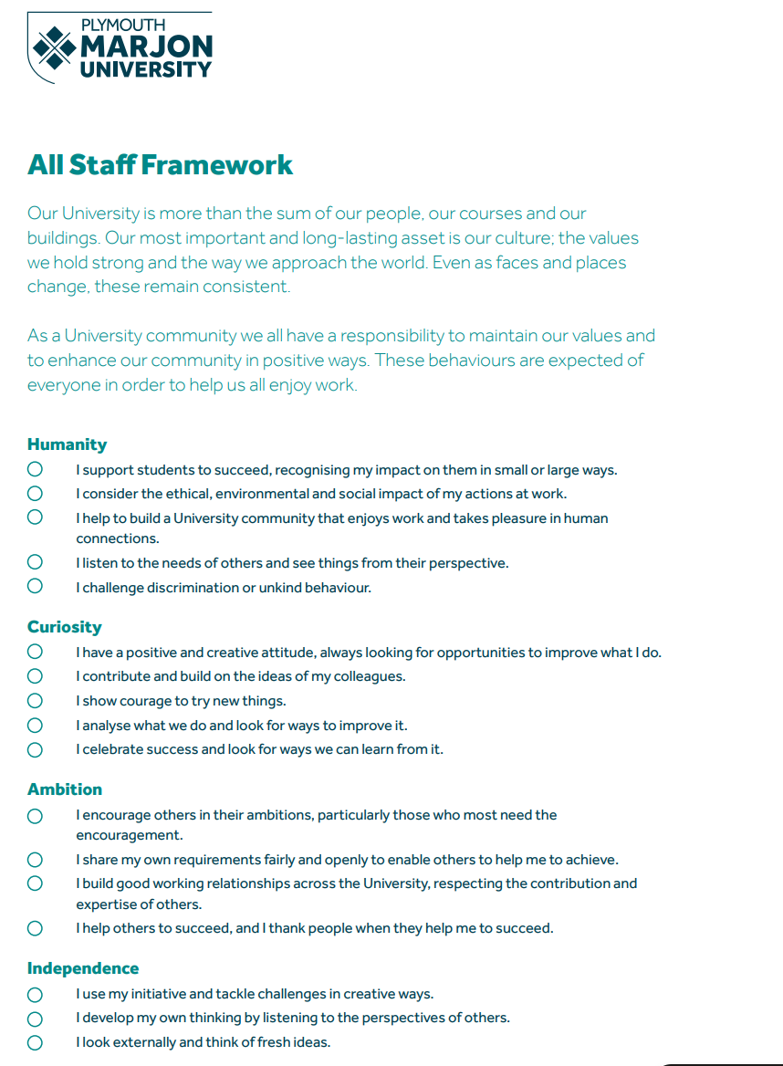

APPENDIX 4: University Leadership & MANAGEMENT Framework


Document Title | Honorary and Visiting Titles Policy
Version | 1.1
Issuing Authority | Senate
Custodian | Research & Knowledge Exchange Office
Last Amended | 16th June 2023
Sensitivity | Unclassified
Circulation | Web publication
Effective from | Date of most recent amendment
Review Date | By 31st August 2027
Effective until | 31st August 2027
History | V1.0 approved by SMT 18/01/22. Submitted to Senate via UBoS.  UBoS approved 09/02/22. Senate approved 02/03/22. Renewal following annual review approved by Senate on 10th May 2023.  V1.1 approved by Senate, 5th July 2023.  V1.1 renewed at Senate, 3rd July 2024. RKEC’s recommendation for review of the policy every 3 years (and as required), rather than annually, has been approved.  v1.2 updated Nov 2025 to condense content; added clarity around behaviours, contractual rights, and renunciation/withdrawal of titles.  Approved via RKEC Chair’s action 17th Dec 2025.

