Staff and Student Engagement Policy: Sustainability
2020-2030

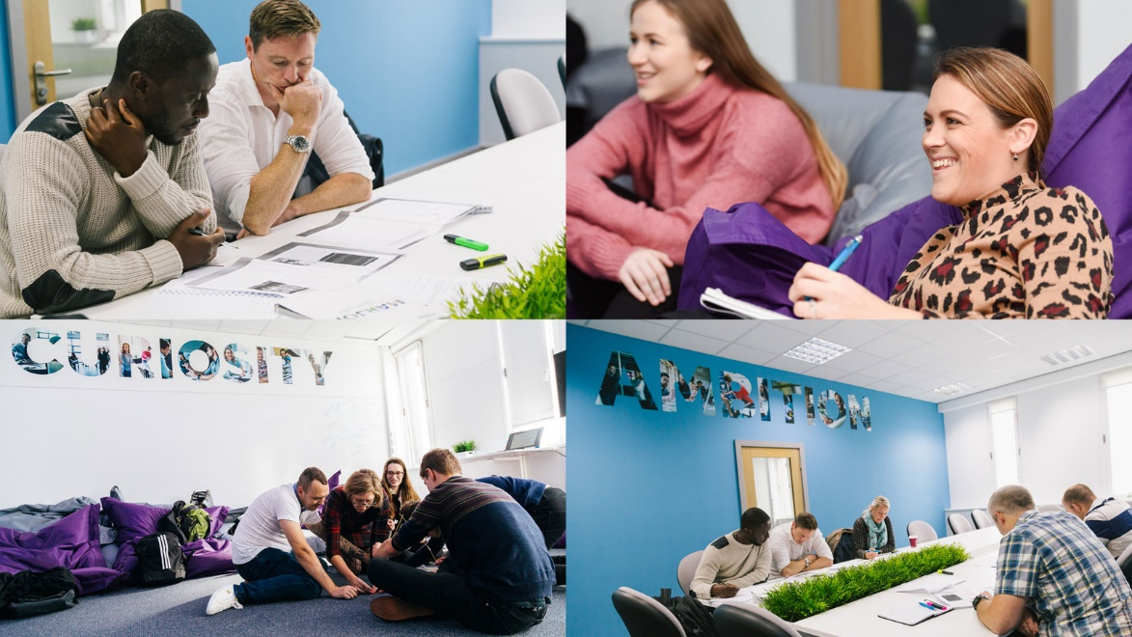

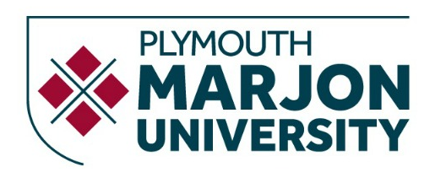

- Staff and Student Engagement Policy: Sustainability
Staff and student engagement is an important aspect of our Sustainability Strategy.
The University has a Learning and Teaching Strategy 2020-2025 document that can be found here.
This document outlines our vision to inspire creative and engaging learning environments, to embrace the holistic development of all those within the University community and to deliver an authenticity of experience to empower self-realisation.
Included in this strategy is our policy which states: “Curricula will ensure that learning, teaching and assessment is inclusive and supports the success of all students, developing graduate employability skills and attributes, developing students’ social capital as well as students’ understanding of their social and environmental responsibilities”.

Objectives:
- Increase student and staff engagement with Marjon’s sustainability agenda.
- For every member of Marjon’s community to feel involved in the decision making of sustainability project ideas and project prioritisation.
- Student and staff voice is important to us, therefore providing a platform for people to speak to our sustainability team is imperative.
- To assist the environmental society with projects and campaigns they wish to be involved in.
- Provide a sustainability champions group for staff and students who wish to be involved with the implementation of the university’s sustainability strategy.
- Provide opportunities for sustainability education for both staff and students.
- Provide opportunities for research and knowledge exchange around sustainability.

Progress to date:

Initiative | Purpose
Annual Marjon-Zero Climate Conference | Started annual Marjon Zero Climate Conferences for staff and students. These conferences involve presentations around sustainability, a plant-based lunch, sustainability workshop and plant-based cooking lessons. Feedback from the conference held in November 2021 was that it was an insightful, educational day for all who were in attendance.
Sustainability Champions | Marjon has started a Sustainability Champions group for both staff and students to come together monthly to discuss up and coming projects at the university and to discuss any improvements members wish to see at the university.
Change Maker Students | We host some Change Maker students every year that carry out a project with the university allowing them to make a difference on something they care about. This year we have been working with one of our students to introduce food waste bins in onsite accommodation. With Plymouth City Council not having food waste bin collection as an option, Marjon is trying to go above and beyond to organise domestic food waste bin collection. We are currently at the stage of trialling a few bins in our halls with the waste going to our onsite compost heaps. This project benefits both the students who gets to work hard on a project that they are passionate about that will make real tangible change, as well as us as the University who gets to assist our students develop these key skills as well as make positive changes across the University.
Ensuring sustainability is embedded into the curriculum | Each of our programmes go through an approval process to ensure sustainability is embedded within the course. The university also recommends use of the Future Fit Framework and strategy for the implementation of Education for Sustainable Development (ESD). We also follow the Quality Assurance Agency and Advance HE guidance for staff and institutions on ESD. The aim of the guidance is to support all students to acquire the skills necessary to develop values and take actions to transition society towards a sustainable future. The guidance gives advice and support on curriculum design, as well as teaching, learning and assessment approaches
Carbon literacy training | Marjon University is starting to roll out carbon literacy training for students and staff through 2022-23. This is being run through The Carbon Literacy Project whereby one of our PhD students will be doing the training course, then training others at Marjon. Carbon literacy training gives our staff and students an awareness of the carbon dioxide costs and impacts of everyday activities, and the ability and motivation to reduce emissions, on an individual, community and organisational basis. We hope to roll out this training beyond the institution over the next few years.
Marjon’s Futures Team | Marjon has a Careers, Employability and Enterprise team, which offers student centred and professional information and guidance on career development learning, employability skills and enterprise as well as providing curriculum input. Supporting the Marjon values, Futures supports experiential learning via placements, work experience, part-time jobs, and international opportunities; business and enterprise development; funding to support opportunities and guidance to support career development and acquisition of key employability skills. Futures online provides web-based digital information, advice, and guidance to support the work of the Futures team and wider Marjon community. Marjon also continues to support our graduates indefinitely with our careers services.
Social Enterprise | More than ever before, graduates are reporting that they need to believe the work they are doing has a social purpose. Our students seek employment and lifestyles that enable them to contribute to the social, cultural and environmental wellbeing of their communities, society and the world around them. They see their degree not simply as a route to a career but as an enabler to help them make a difference in the wider community. Marjon University has achieved the Social Enterprise Mark CIC which is the UK and international certification authority that safeguards social enterprise credentials. Only organisations that can prove they put people and planet before shareholder profit are awarded a license to display the Social Enterprise Mark. As the number one university in the UK for social mobility, we are proud to be recognised for our commitment to helping local communities and the broader southwest peninsula to thrive and prosper. Our accreditation with the Social Enterprise Mark recognises that we put ethics, civic engagement, social and environmental justice and sustainable economic development at the heart of the student experience. We show our students how we apply in practice the values and knowledge that we teach and how they too can be part of a social enterprise culture.
CPD (continued professional development) opportunities | CPD (continued professional development) opportunities are offered by the university. These free courses are both hosted internally as well as external opportunities. These CPD events are published on our internal Antler page for staff to book onto. Sustainability in both teaching and research is a strong element of this CPD offer.
SCION group (Sustainability, Creativity & Innovation) | Marjon hosts events and Academy Lectures throughout the year run by our SCION research and knowledge exchange group (Sustainability, Creativity & Innovation). SCION hosts seminars and workshops on research and knowledge exchange by members and offers opportunities for colleagues across the university to network and make connections around sustainability, creativity and innovation.  Event hosted to date:  - Creative Pedagogies for Sustainability and Citizenship  - Creative Universities: Reimagining Education for Global Challenges and Alternative Futures  - An annual ‘All Staff Curiosity Conference’ whereby this years theme (2022) is around de-colonising the curriculum, equality and inclusion.  - Researcher Developer Series: Research-informed Teaching and Sustainability  - Inspiring sustainable practice: moving beyond preaching to the converted  - How to Have a Good Life and Save the Planet Too  - Response and responsibility: the role of universities in a more sustainable future  - Response and responsibility - sustainable future  - Social mobility  Staff are kept up to date with these conferences and opportunities to get involved in SCION through their frequent newsletter.
Living Lab | Marjon also has student research projects, some specifically looking at sustainability on campus. A current example involves research into the Hidden Curriculum of sustainability on campus entitled, ‘Making the invisible visible’. The research is using visual methods offering an innovative approach to exploring staff and student’s perspectives of sustainability on campus. Autophotography (through a photo competition) and photo elicitation in focus groups where staff and student’s discuss images of sustainability on the campus.  Given the focus on spending time in ‘nature’ and green spaces in the DfE strategy, as well as an interest in ‘net zero’ activities, there is an opportunity for the research to contribute to learning from campus developments at Marjon (including allotments, beehives, nature survey – but also the ground source heat pump and solar panels) – as well as encouraging people to think about and discuss sustainability on campus. Some of our PhD student work on nature connection and communication of sustainability also links to the campus.  Other aspects of student involvement in living lab projects are focused on inclusion and health and well-being. For example, student-led clinics help promote positive behaviour change in patients with long term conditions. Student learning and positive outcomes for the community act in synergy to cement Marjon’s position as a civic university.

