**MSU**

**SOCIETIES CODE OF CONDUCT**

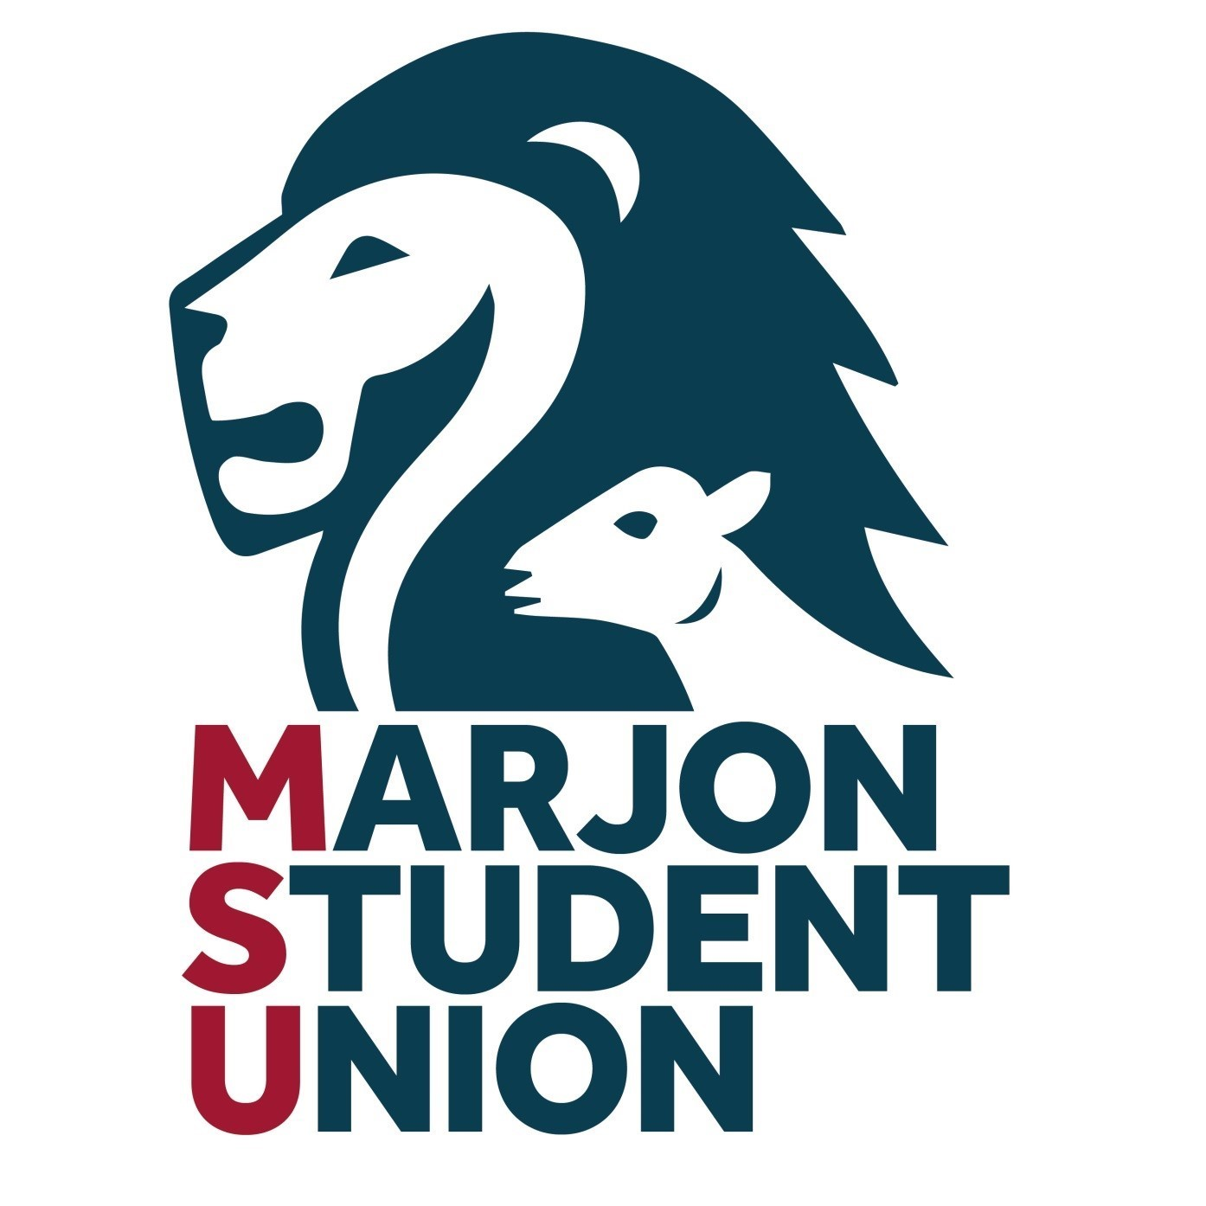

Created: 24th September 2019

Last Review: May 2025

Next Review Date: Dec 2026

By: The General Manager

**MSU SOCIETIES CODE OF CONDUCT**

**[Name of Society]**

This document informs members of the above society of the requirements for safe participation in their society activities. Please read it carefully.

Marjon Student’s Union (MSU) does not condone any activities outside the remit of this code of conduct and encourages individuals, in the interests of their personal safety, not to participate in activities not covered by this document.

**Committee**

The committee shall be elected democratically by the members of the society at the society’s annual general meeting (AGM).

**The Society committee shall:**

1. Ensure the duty of care to their members within all activities undertaken by the society whilst working within the Health and Safety guidelines of MSU and the University.
2. Act in accordance with the principles of MSU and Plymouth Marjon University’s Equal Opportunities Policy and not discriminate on any grounds including but not limited to sexuality, race, gender, age or disability.
3. Make a commitment to providing a quality service to their members.
4. Promote and facilitate the activities and interests of the society rather than their own interests and activities.
5. Act professionally and responsibly in all matters regarding their society and MSU.

**The Society members (ordinary and committee) shall:**

1. Conduct themselves accordingly as representatives of their Society, MSU and the University.
2. Comply with MSU’s constitution and all other relevant MSU policies.
3. Respect the rights and dignity of others and ensure that threatening or intimidating behaviour is not tolerated towards members, students, staff or the public.

**Social Activity**

1. Members are reminded that when participating in the Society’s social activities they are representing MSU and Plymouth Marjon University.
2. Behaviour deemed to be unacceptable by either MSU or the University may result in disciplinary action taken against the individuals or the society of a whole.
3. The society’s aim is to ensure that every member has an enjoyable time and no pressure be placed on any member to do anything they may not enjoy.
4. The members of the society committee are responsible for the welfare of all the members and will take necessary measures to ensure that an adequate level of safety is maintained.
5. It is each individual’s choice if they attend society socials. Non-attendance will not be a barrier to full participation in other society activities.
6. All members must respect the rights, dignity and worth of all other society members regardless of age, gender, ability, race, cultural background, religious beliefs or sexual identity.

**Affiliations (if applicable)**

1. (Insert the name and contact details for the organisation/association/charity your society may be affiliated with. Please also indicate the benefits of this affiliation to members.

**Facilities (if applicable)**

1. Members are required to abide by the rules and regulations set down by MSU and Plymouth Marjon University when using its facilities.
2. Members are required to abide by the rules and regulations of each and any operator of any external facilities used by the society.
3. Members should leave the facilities in the condition that they found them in as far as is reasonably practical.
4. If members require a room booking, they must contact the MSU and they will complete this action with the members.

**Health and Safety Responsibilities**

1. The committee members are responsible for the health and safety within the society.
2. Each individual member should ensure they familiarise themselves with the risks inherent in any activity undertaken and should take every recognised precaution to avoid risk to themselves and others.

**First Aid/Accident Reporting**

1. Any injuries/incidents or near misses must be reported to the MSU.
2. First Aid kits should be accessible for all society events. These can be obtained from the campus security office.

**Society Specific**

1. (Please enter here any society specific items you wish to be a part of your society code of conduct)